**Level of Risk Matrix**

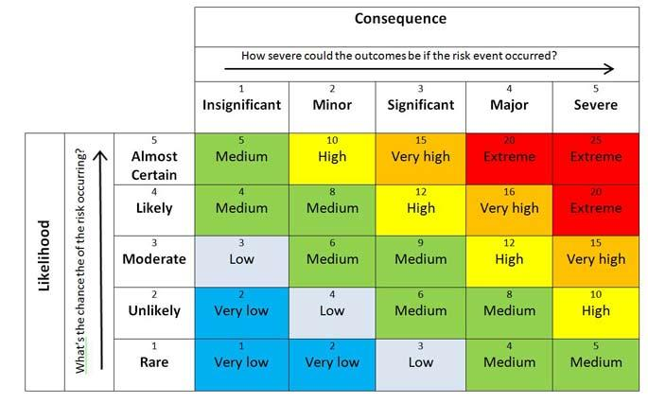

**Placement initial risk assessment / impact**

|  |  |
| --- | --- |
| **Name of young person** |  |
| **Date of admission** |  |
| **Social worker** |  |

**Risk Assessment to be updated**

|  |  |  |  |
| --- | --- | --- | --- |
| **Risk/Hazard** | **Yes**  **No** | **Summary** | **Current Risk assessment**  **Level** |
| **Is there a history or knowledge of violent or risk behaviour?**  e.g. **Criminal Damage**, Vandalised Property, Theft, Assault, Violence To Staff And Peers, Incidents Involving Police, verbal abuse, Aggressive emotional outbursts, **Probation/Youth Offending Service** |  |  |  |
| **Is there a history of harm or abuse from others?**  e.g. **Neglect**, Sexual Exploitation, **Emotional/Psychological Abuse** Including Bullying, Unlawful Restrictions (E.G. Locks On Doors, Physical Restraints Etc), Physical Harm, Financial Abuse |  |  |  |
| **Is there a history of Absconding?**  e.g 1 week, 2 weeks, 3 weeks, |  |  |  |
| **Is there a history of drug or alcohol abuse?**  e.g. Class A, **Class B**, Class C, Prescription drugs |  |  |  |
| **Is the young person known to be racist?** |  |  |  |
| **Has the young person any record of arson?** |  |  |  |
| **Does the young person have or been in possessions of anything which might cause concern?**  e.g. Penknife, Alcohol, **Drugs**, Fire Arms, Gang Affiliation |  |  |  |
| **Is the young person involved or been involved in sexual exploitation or sexual abuse?** |  |  |  |
| **Does the young person have a history of making any sexual allegations?** |  |  |  |
| **Has the young person been known to have ever taken an overdose?** |  |  |  |
| **Has the young person shown any self harming behaviour?**  e.g. Suicidal behaviour, Self-injury, Suicidal Ideation, Self-neglect  Substance misuse e.g. Alcohol/drug abuse |  |  |  |

**In summary, please describe any risk impacts the young person may present to others at the unit:**

**What Measures are available to deal with these risks ?**

**Please confirm recommendations (Yes /No)**

Solo placement ……………... Shared accommodation ………….. Outright placement disqualification ……………….